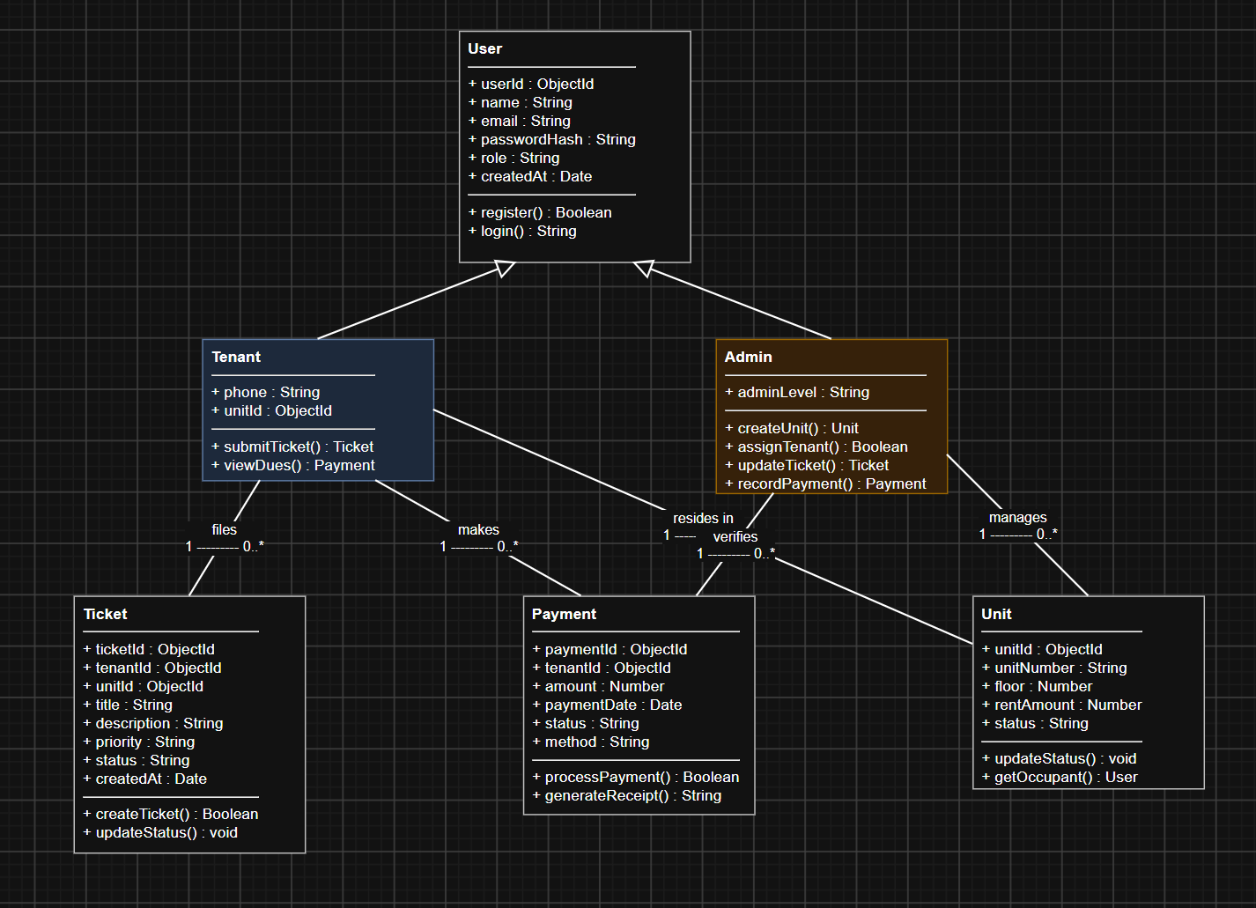
Class Diagram Specification
Project Name: Apartment360 – Apartment Housing Management System
Document Version: 1.0
1. Class Dictionary & Data Dictionary
Class Name | Stereotype / Type | Description
User | Abstract Superclass | Represents common identity and authentication properties shared by all system actors.
Tenant | Subclass (User) | Represents a resident living in an apartment unit with access to ticket submission and rent balance views.
Admin | Subclass (User) | Represents property management staff authorized to manage units, tenants, tickets, and payments.
Unit | Domain Entity | Represents an apartment unit within the property, tracking occupancy, floor, and monthly rent.
Ticket | Domain Entity | Represents a maintenance request logged by a tenant and managed by an administrator.
Payment | Domain Entity | Represents a financial transaction recording rent dues and payment verification.
2. UML Class Diagram (Mermaid)
Code snippet
classDiagram
class User {
+ObjectId userId
+String name
+String email
+String passwordHash
+String role
+Date createdAt
+register() Boolean
+login() String
}

class Tenant {
+String phone
+ObjectId unitId
+submitTicket(title, desc, priority) Ticket
+viewDues() Payment
}

class Admin {
+String adminLevel
+createUnit(number, floor, rent) Unit
+assignTenant(tenantId, unitId) Boolean
+updateTicketStatus(ticketId, status) Ticket
+recordPayment(tenantId, amount) Payment
}

class Unit {
+ObjectId unitId
+String unitNumber
+Number floor
+Number rentAmount
+String status
+updateStatus(newStatus) void
+getOccupantDetails() User
}

class Ticket {
+ObjectId ticketId
+ObjectId tenantId
+ObjectId unitId
+String title
+String description
+String priority
+String status
+Date createdAt
+createTicket() Boolean
+updateStatus(status) void
}

class Payment {
+ObjectId paymentId
+ObjectId tenantId
+Number amount
+Date paymentDate
+String status
+String method
+processPayment() Boolean
+generateReceipt() String
}

User <|-- Tenant : Inheritance
User <|-- Admin : Inheritance
Tenant "1" -- "0..1" Unit : resides in
Admin "1" -- "0..*" Unit : manages
Tenant "1" -- "0..*" Ticket : files
Unit "1" -- "0..*" Ticket : associated with
Tenant "1" -- "0..*" Payment : makes
Admin "1" -- "0..*" Payment : verifies
3. Relationships & Multiplicity Explanations
- Inheritance (User $→$ Tenant / Admin):
  - Both Tenant and Admin inherit core identity fields (userId, name, email, passwordHash) and methods (register(), login()) from User.
- Tenant to Unit (1 to 0..1):
  - A Tenant can be assigned to at most one Unit at any given time (0..1). A Unit holds at most one active primary occupant.
- Tenant to Ticket (1 to 0..*):
  - One Tenant can submit zero or many (0..*) maintenance Ticket entries over time.
- Unit to Ticket (1 to 0..*):
  - Every Ticket is linked to a specific Unit to help property managers isolate physical building issues.
- Tenant to Payment (1 to 0..*):
  - One Tenant generates multiple Payment records throughout their lease period.
- Admin to Units / Payments / Tickets (1 to 0..*):
  - An Admin has operational authority to create and update multiple Unit, Ticket, and Payment records.

